**Inclass Programming Assignment – 2**

Avanthi Madhuri

700764030

**Github Link:** <https://github.com/Avanthireddy04/NeuralNetwork_assignments/tree/main/ICP_2>

**Problem 1:** To take two strings from the user: first_name, last_name. Pass these variables to the fullname function that should return the (full name).

**Input:** 2 Strings

**Output:** String

**Solution:**1. The user strings are taken, stored in the “first_name”, “last_name” variables, sent to the function “full_name” and concatenated into a single string using the ‘+’ operator.

2. The user string is taken, stored in the “original_string” variable, sent to the function “string_alternative”.

3. Then alternate characters are returned from the function using the slicing operator with a step of 2.

**Code:**

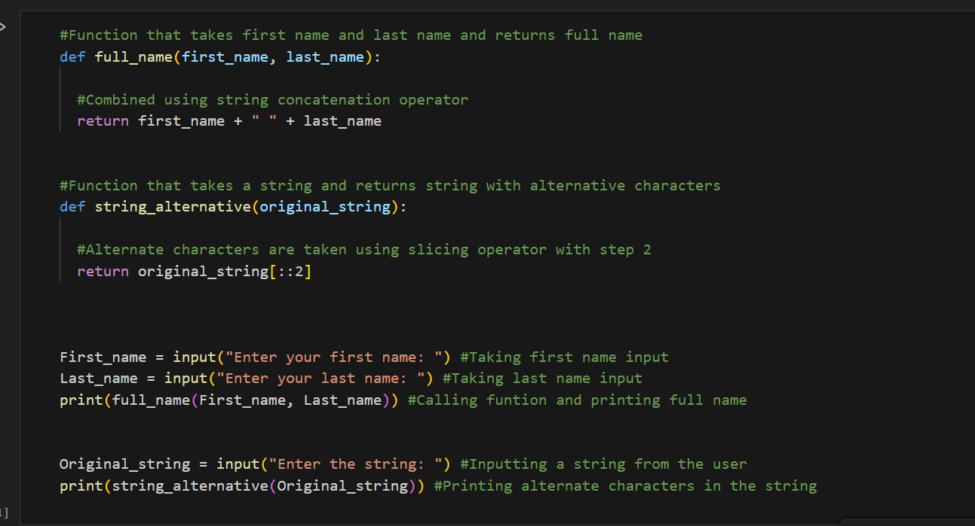

**Problem 2:** To find the word count in a file (input.txt) for each line and then print the output.

**Input:** input.txt file

**Output:** output.txt file

**Solution:**

1. input.txt file is uploaded into the jupyter Notebook and is accessed with open() method in read only access mode.

2. Contents in the file are accessed and stored in a list called “contents”.

3. The words in the list count are maintained in a dictionary and are used for writing the output into a file.

4. The open() is used to create a file called “output.txt” and contents in the dictionary are copied to the file and are downloaded to the local.

**Code:**

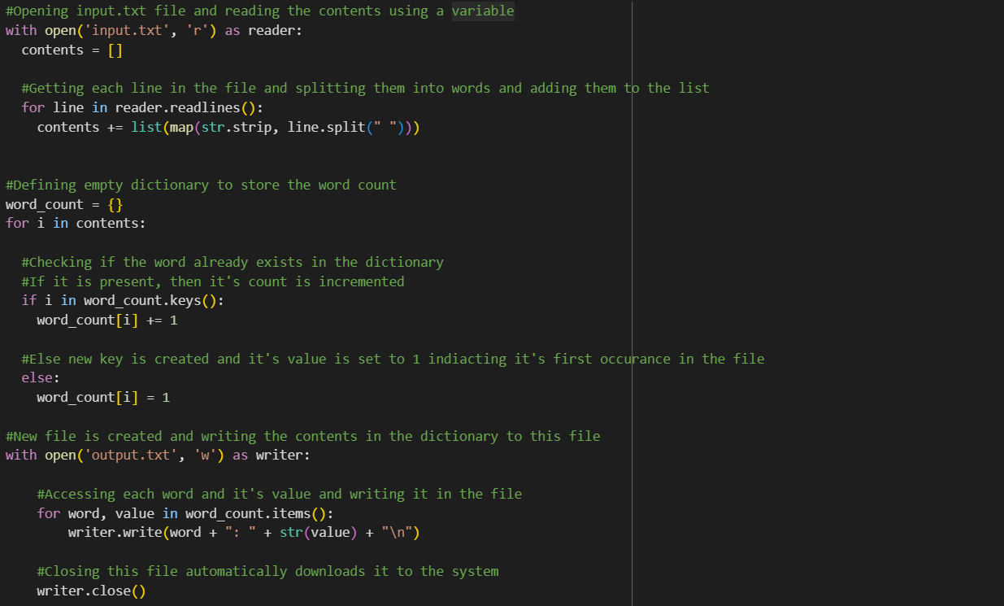

**Output:**

**input.txt:**

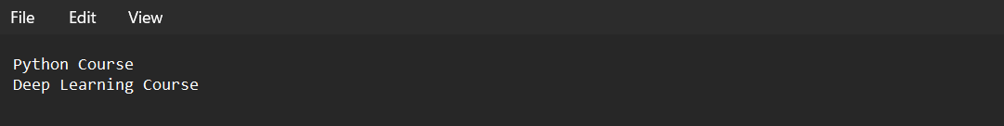

**Output.txt:**

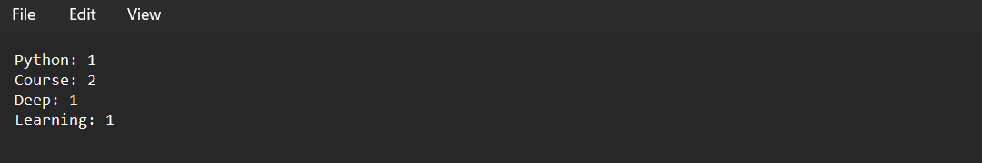

**Problem 3:** To read heights (inches.) of customers into a list and convert these heights to centimeters in a separate list using: 1) Nested Interactive loop 2) List comprehensions

**Input:** List

**Output:** List

**Solution:**

1. The program takes a series of heights in centimeters as input from the user.

2. First, the heights are converted into inches using a loop. Second, heights are converted into inches using list comprehension.

3. The resultant lists are printed on the console.

**Code:**

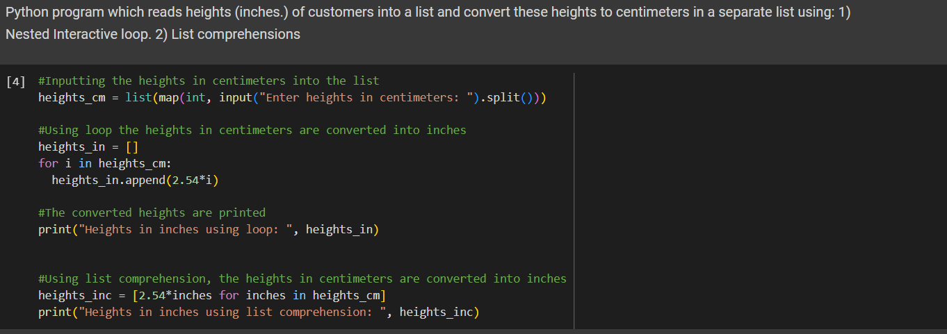

**Output:**

